Topic 5 : Chemical Energetics

1.
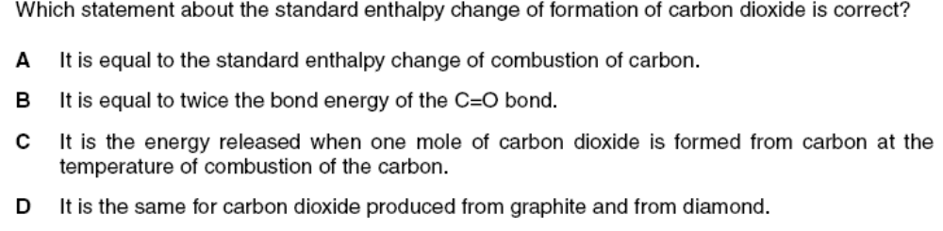

2.
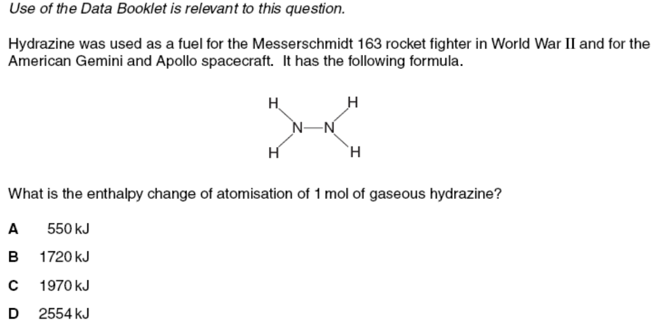

3.
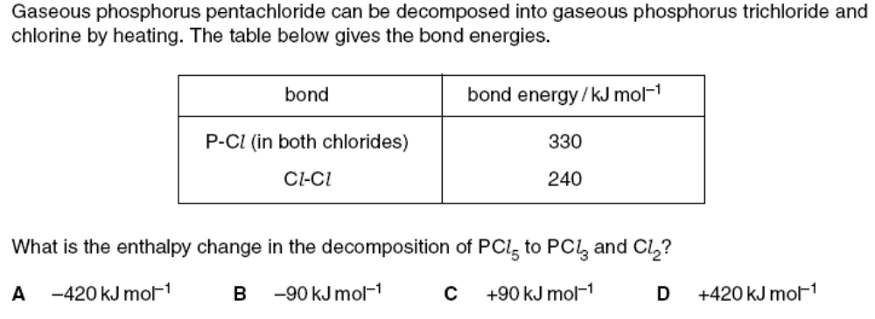

4. 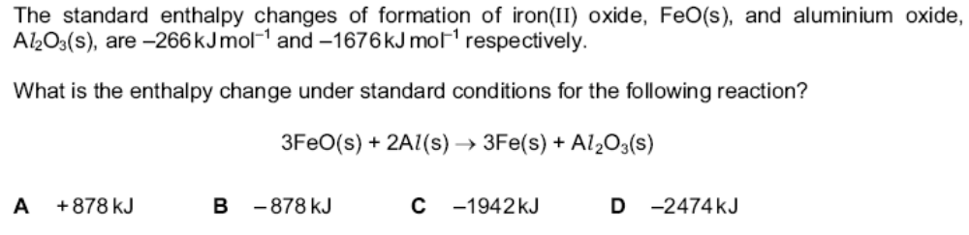

5.
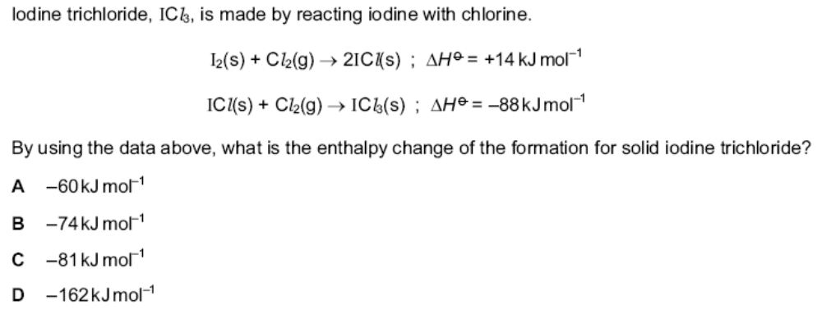

6.
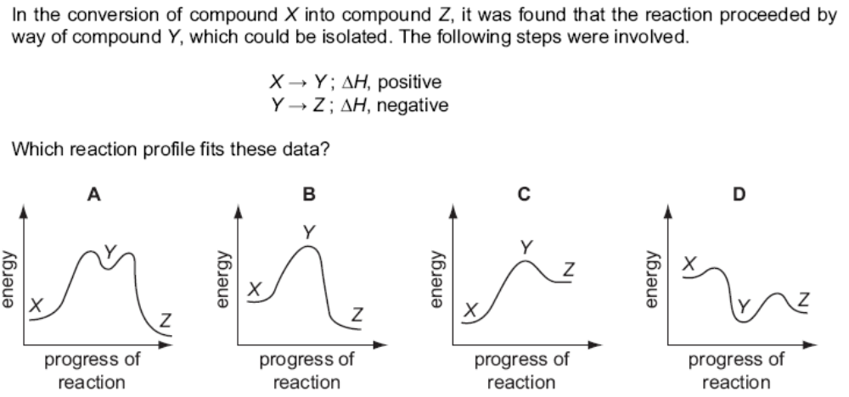

7.
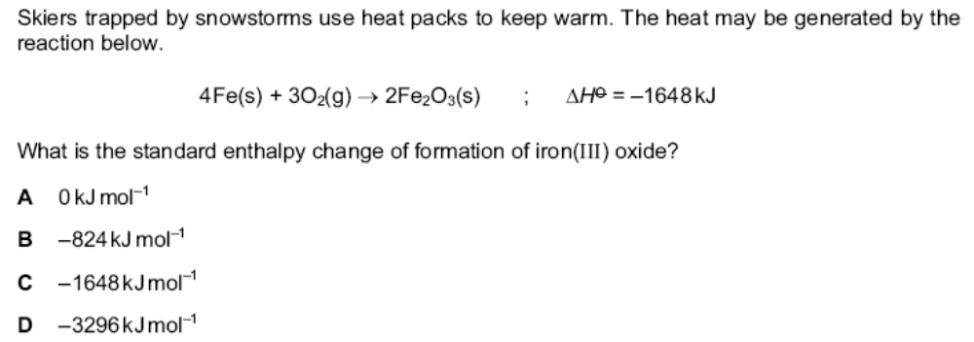

8.
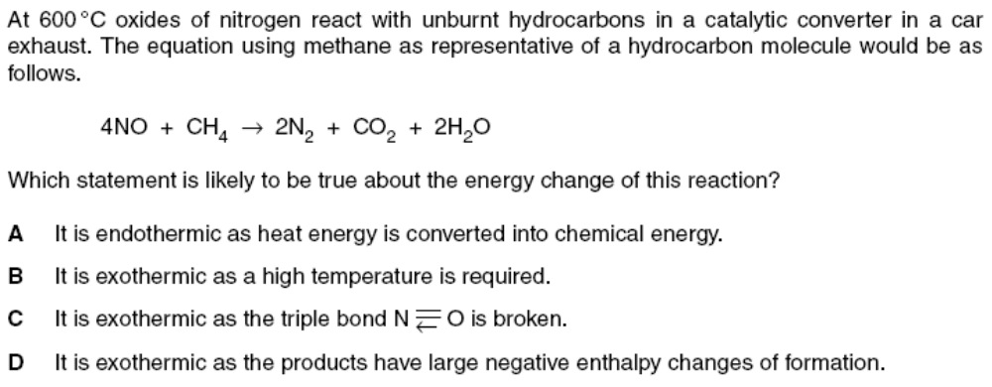

9.
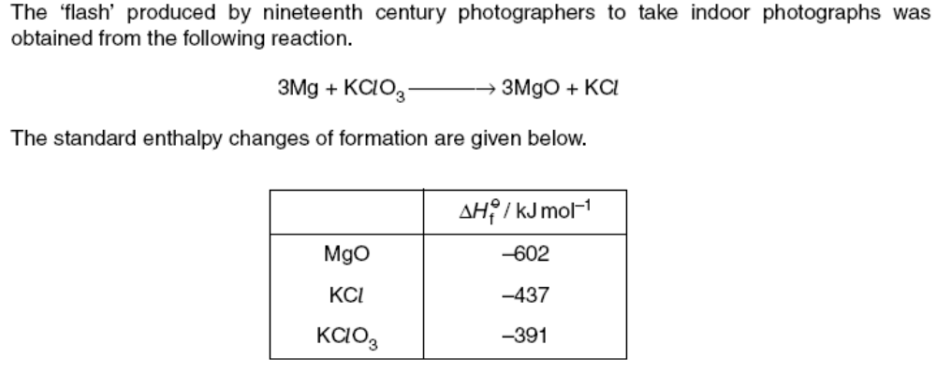

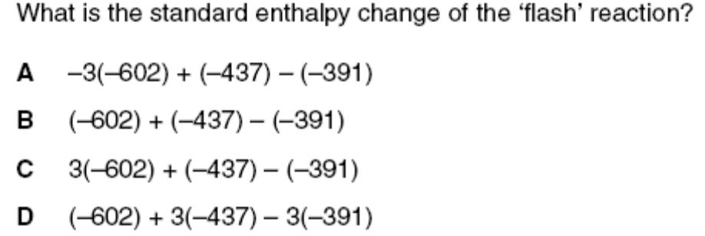

10.
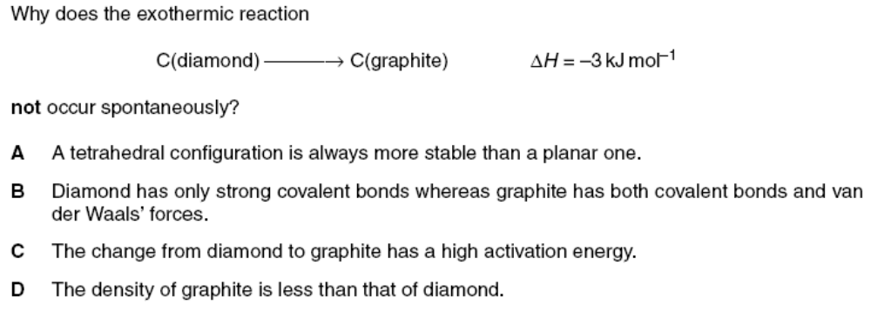

11.
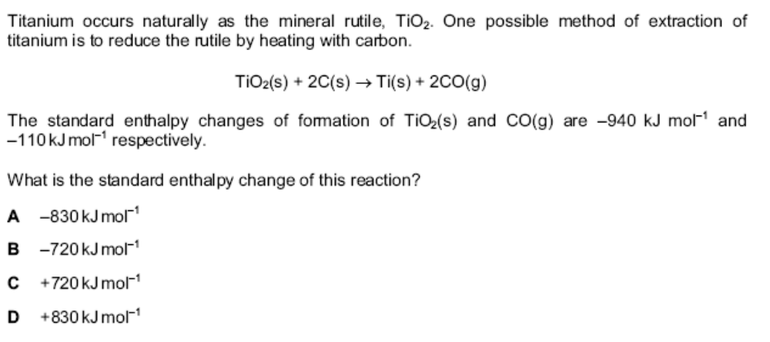

12.
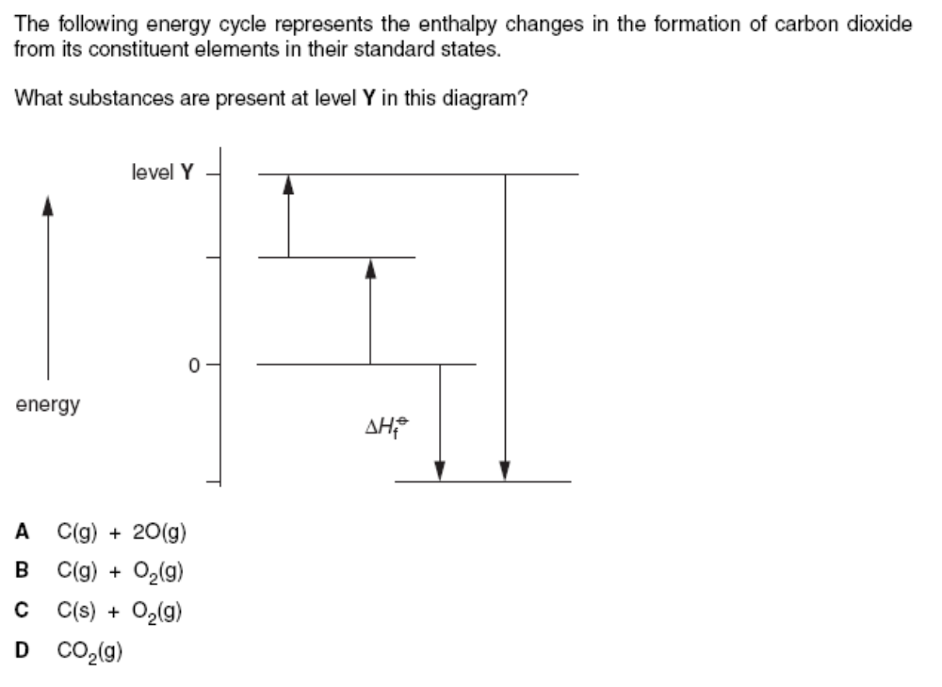

13.
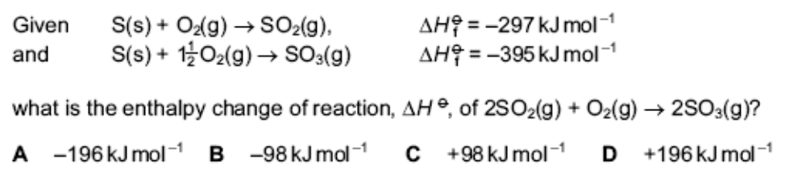

14.
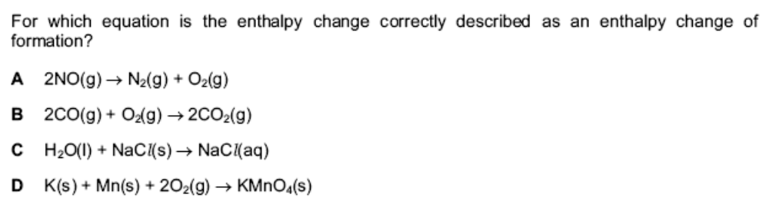

1.
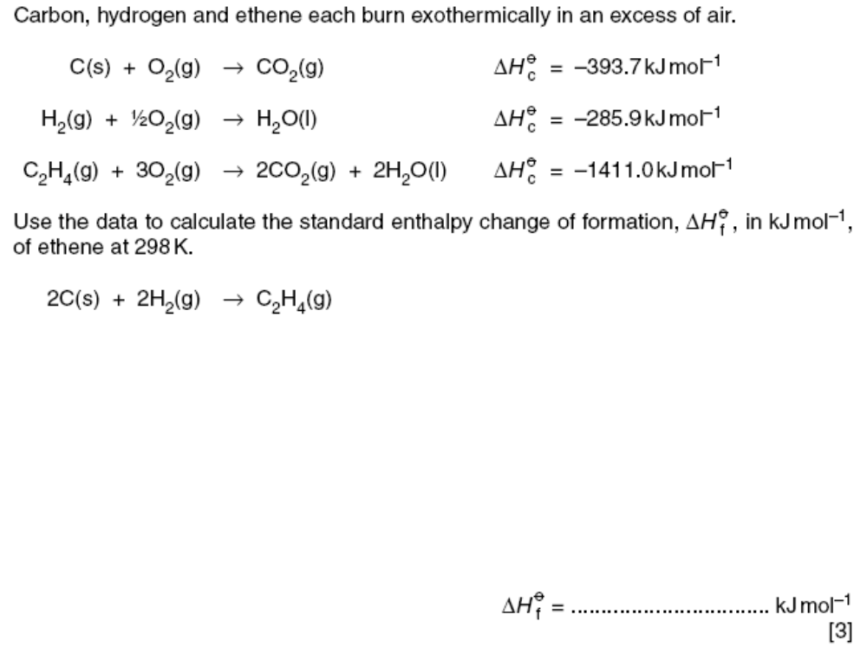
2.
The hydrocarbon, heptane C₇H₁₆, is one of the hydrocarbons present in petrol. Its combustion reaction with oxygen provides some energy to propel a vehicle.

- Define the term standard enthalpy change of combustion.

………………………………………………………………………………………

………………………………………………………………………………………

………………………………………………………………………………………
[2]
b) Write an equation to show the complete combustion of heptane. [1]

- Use the standard enthalpy change of formation data below to calculate the
standard enthalpy of combustion of heptane. [2]

Compound | ΔH_{f} ^{θ} / kJmol⁻¹
C₇H₁₆ (l) | -224.4
CO₂ (g) | -393.5
H₂O (l) | -285.9

